Executive Summary
This purpose of this analysis is to identify the key factors influencing the price differential of used cars and determine whether a predictive model can effectively be used to forecast. The hypothesis suggests that factors such as make, model, body, transmission, year, condition, and odometer significantly affect the difference between the actual sale price and the market value (MMR). The development of a regression model was used to understand how well these features can predict price differentials and whether the model generalizes well for new data.
The dataset used in this study was sourced from Kaggle’s “Vehicle Sales Data” and contains 25,000 rows after data reduction for computational efficiency. Key variables include make, model, year, transmission, body, condition, and odometer. Data preprocessing steps included handling missing values, encoding categorical variables, outlier removal using IQR, and assessing multicollinearity with VIF. Feature selection was performed using p-values and Lasso regression. The final model was evaluated using R-squared, Mean Squared Error (MSE), Residual Standard Error (RSE), and the Shapiro-Wilk test for normality.
Data Preparation and Methodology
Data preprocessing was conducted by first handling of missing values imputing the mean for continuous variables. Categorical variables were encoded, and outliers were removed using the Interquartile Range (IQR) method. The distribution of key variables before and after outlier removal can be seen in the following images:
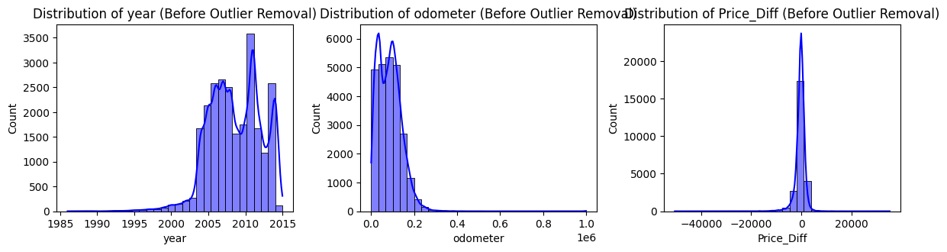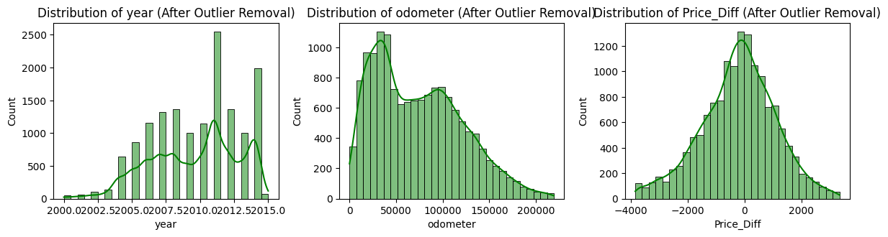
Additionally, multicollinearity was evaluated using the Variance Inflation Factor (VIF) to make sure that predictor variables were not correlated. The VIF variables with values greater than 10 were removed to reduce multicollinearity and improve model performance.
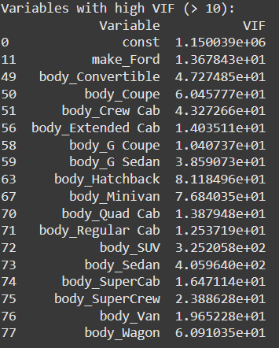
Feature selection was then performed to identify the most relevant variables for the model. To select statistically significant features, the P-values were calculated and only those with a significance less than 0.05 were retained. Lasso regression was then utilized to further refine the model by penalizing less relevant features. The top 10 Lasso regression coefficients are displayed in the chart below highlighting the most influential features in predicting price differentials.
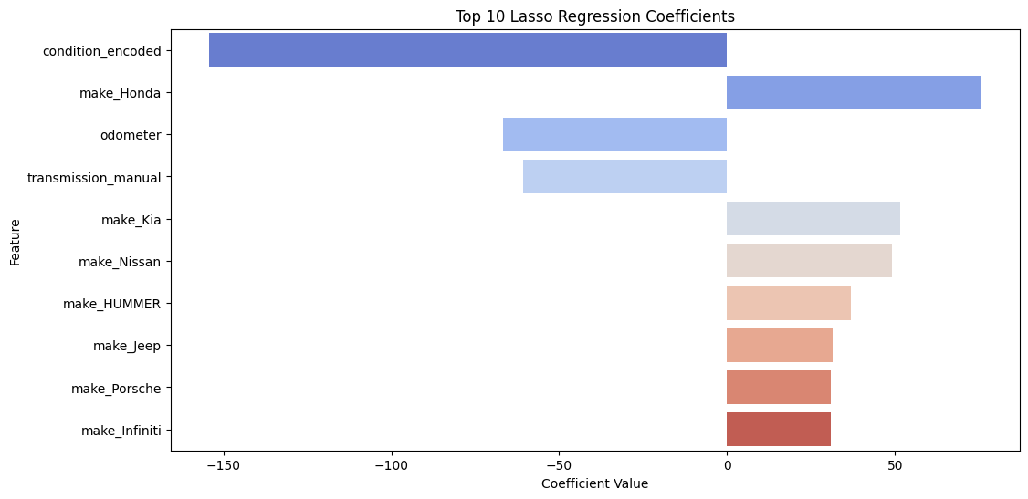
Model construction was performed using multiple linear regression and the effectiveness of the model was evaluated using several performance metrics. These metrics include R-squared, Mean Squared Error (MSE), Residual Standard Error (RSE), and the Shapiro-Wilk test. All were considered to determine the model's quality and its reliability.
Findings
The regression model showed a statistically significant relationship between the selected features and price differentials, but it demonstrated low explanatory power (R-Squared = 0.031). Although the model identified key predictors of price differentials, its predictive accuracy was limited. The Mean Squared Error (MSE) was found to be 1,622,434, and the Residual Standard Error (RSE) was high at 1,288.15, indicating significant unexplained variance.
Limitations
The key limitation of the study stems from the use of linear regression, which assumes linear relationships and normally distributed residuals. These assumptions were not entirely satisfied due to the presence of potential nonlinear relationships and unconsidered interactions between variables. Additionally, important features such as geographic location were not included in the dataset potentially hindering the model’s performance.
Proposed Actions
Future analyses should incorporate broader datasets that include consumer attributes (e.g., economic or behavioral data), regional pricing trends, and explore alternative machine learning models, such as decision trees or random forests. These models have been shown to offer better performance in similar studies, with an R² of 0.95 in previous work (Natani, 2022). By incorporating these factors, the predictive power of the model could improve significantly.
Expected Benefits
As currently constructed the model offers limited accuracy. However, the model does provide a baseline understanding of the key factors affecting used car pricing and highlights areas for further refinement. The development of an improved predictive model could help sellers align their pricing more closely with market conditions and reduce negotiating time. Ultimately, such a model could enhance revenue and increase buyer trust by providing more accurate pricing predictions.
Sources
Kaggle Dataset: Vehicle Sales Data (https://www.kaggle.com/datasets/syedanwarafridi/vehicle-sales-data/discussion/485488).
Natani, A., Pandit, E., Parekh, H., & Pashte, P. (2022). Used car price prediction using machine learning. International Journal for Research in Applied Science and Engineering Technology, 9(12), 355-360.

